**ISO 9000:2015 principles of Quality Management**

The ISO 9000:2015 and ISO 9001:2015 standards are based on seven quality management principles that senior management can apply to promote organizational improvement.

**[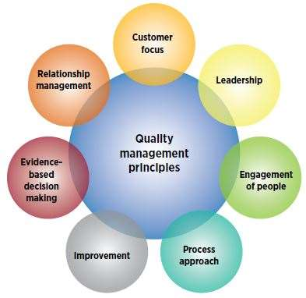](https://asq.org/quality-progress/2018/01/standards/under-the-wire.html)  
ISO 9000 Quality Management Principles**

1. Customer focus
   * Understand the needs of existing and future customers
   * Align organizational objectives with customer needs and expectations
   * Meet customer requirements
   * Measure customer satisfaction
   * Manage customer relationships
   * Aim to exceed customer expectations
   * Learn more about the customer experience and customer satisfaction
2. Leadership
   * Establish a vision and direction for the organization
   * Set challenging goals
   * Model organizational values
   * Establish trust
   * Equip and empower employees
   * Recognize employee contributions
   * Learn more about leadership
3. Engagement of people
   * Ensure that people’s abilities are used and valued
   * Make people accountable
   * Enable participation in continual improvement
   * Evaluate individual performance
   * Enable learning and knowledge sharing
   * Enable open discussion of problems and constraints
   * Learn more about employee involvement
4. Process approach
   * Manage activities as processes
   * Measure the capability of activities
   * Identify linkages between activities
   * Prioritize improvement opportunities
   * Deploy resources effectively
   * Learn more about a process view of work and see process analysis tools
5. Improvement
   * Improve organizational performance and capabilities
   * Align improvement activities
   * Empower people to make improvements
   * Measure improvement consistently
   * Celebrate improvements
   * Learn more about approaches to continual improvement
6. Evidence-based decision making
   * Ensure the accessibility of accurate and reliable data
   * Use appropriate methods to analyze data
   * Make decisions based on analysis
   * Balance data analysis with practical experience
   * See tools for decision making
7. Relationship management
   * Identify and select suppliers to manage costs, optimize resources, and create value
   * Establish relationships considering both the short and long term
   * Share expertise, resources, information, and plans with partners
   * Collaborate on improvement and development activities
   * Recognize supplier successes
   * Learn more about supplier quality and see resources related to managing the supply chain